Faysal Khatri

CSC220 -- Activity 1

2017-06-03

# Part 1: Unix

Question 3

1. Browse to the home directory using cd /home and then list all contents with ls -a
2. man find
3. $PATH
4. Browns to the bin directory using cd /bin and then list contents beginning with k with ls k*  
   
5. cat *.lst > alllist.txt  
   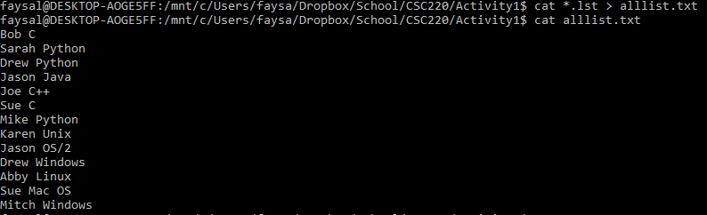
6. head -n10 hello.c  
   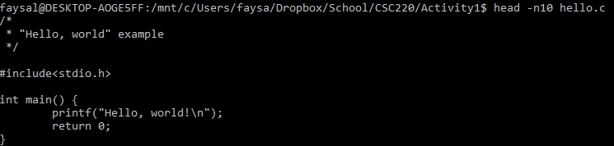

# temps.c

#include<stdio.h>

/* symbolic constants */

#define LOWER 0

#define UPPER 100

**#define STEP 10**

int main() {

**double fahr;**

**int celsius;**

**for (celsius = LOWER; celsius <= UPPER; celsius+=STEP) {**

**fahr = celsius * 9 / 5 + 32;**

/*

%4d - print an integer in a 4 character wide column

\t - tab character

%6.1 - print a floating point number with 1 decimal point

\n - newline

*/

printf("%4d\t%6.1f\n", **celsius, fahr);**

}

return 0;

}

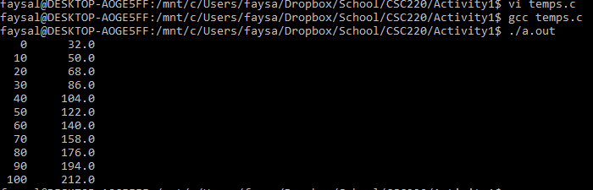

# countlines.c

#include <stdio.h>

int main() {

int c;

int nl=0;

int t=0;

int s=0;

int digits[10];

int i;

/* initializing digits array to zero */

for (i=0; i<10; i++) {

digits[i] = 0;

}

while ( (c = getchar()) != EOF) {

switch (c) {

case '\n':

nl++;

break;

case '\t':

t++;

break;

case ' ':

s++;

break;

case '0': case '1': case '2': case '3': case '4':

case '5': case '6': case '7': case '8': case '9':

digits[c-'0']++; /* c is an ascii character code */

}

}

printf ("There were %d newlines!\n", nl);

printf ("There were %d tabs!\n", t);

printf ("There were %d spaces!\n", s);

for (i=0; i<10; i++) {

printf ("There were %d %ds!\n", digits[i], i);

}

return 0;

}

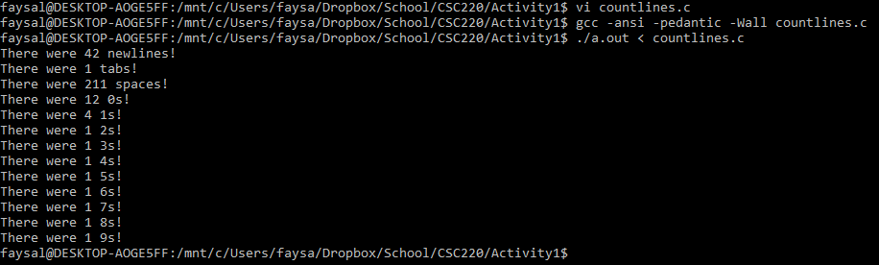

# codeflow.c

#include <stdio.h>

int main() {

#define LOWER 1

#define UPPER 50

int i;

int c = 0;

while (c<LOWER || c>UPPER) {

scanf("%d", &c);

}

for (i=0; i<=c; i++) {

if ( (i%4 == 0) && (i%8 == 0) ) {

printf ("%d:\tffffseven\n", i);

}

else if (i%7 == 0) {

printf ("%d:\tseven\n", i);

}

else if (i%4 == 0) {

printf ("%d:\tffff \n", i);

}

else if (i%5 == 0) {

printf ("%d:\t \n", i);

}

else {

printf ("%d:\t%d\n", i, i);

}

}

return 0;

}

